W**EEKLY PROGRESS REPORT**

BY ANURAG SINGH

MUSIC PLAYER APP

* DATE:14/7/23
* PROJECT OVERVIEW:

The goal of this project is to develop a music player app for android that allows users to play audio files, create playlists, manage their music library, and provide a smooth and intuitive user experience.

* Accomplishments this Week:

1. Understanding the project objectives.
2. Understanding the app's core features and functionality, including audio playback, playlist creation, and library management.
3. Setting up the music player interface.
4. Setting up the basic functionality to play , pause and stop the music.
5. Setting up the Volume Seekbar in the music player
6. Understanding the layout management.

* Setting up the interface of the iSangeet app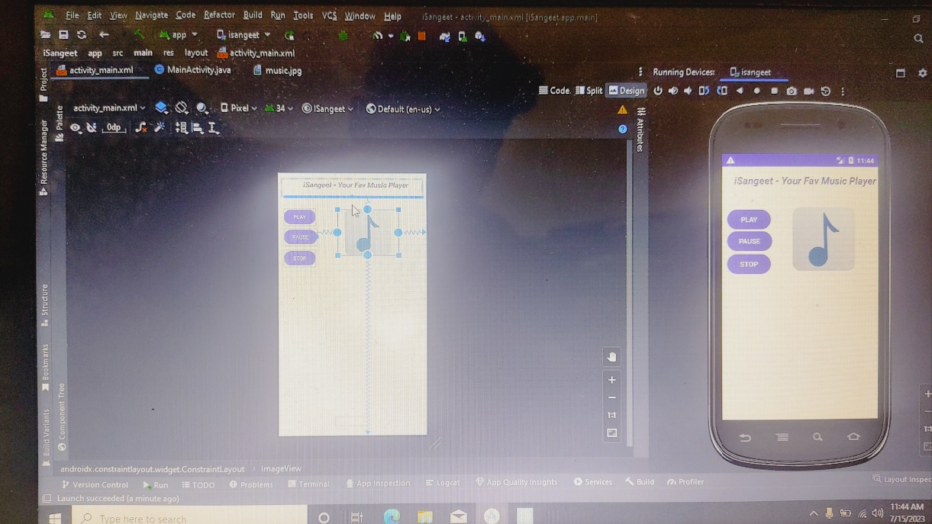:
* 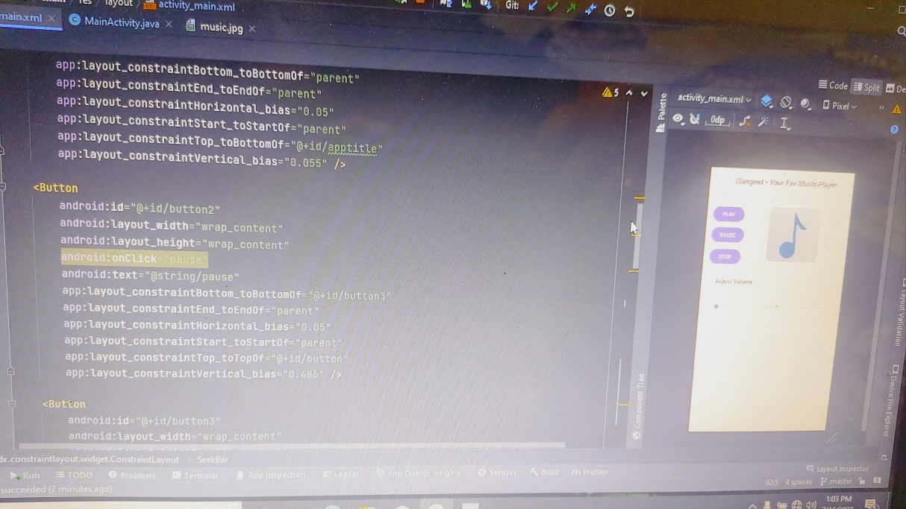
* **Setting up the Buttoons of play pause and Stop in player**

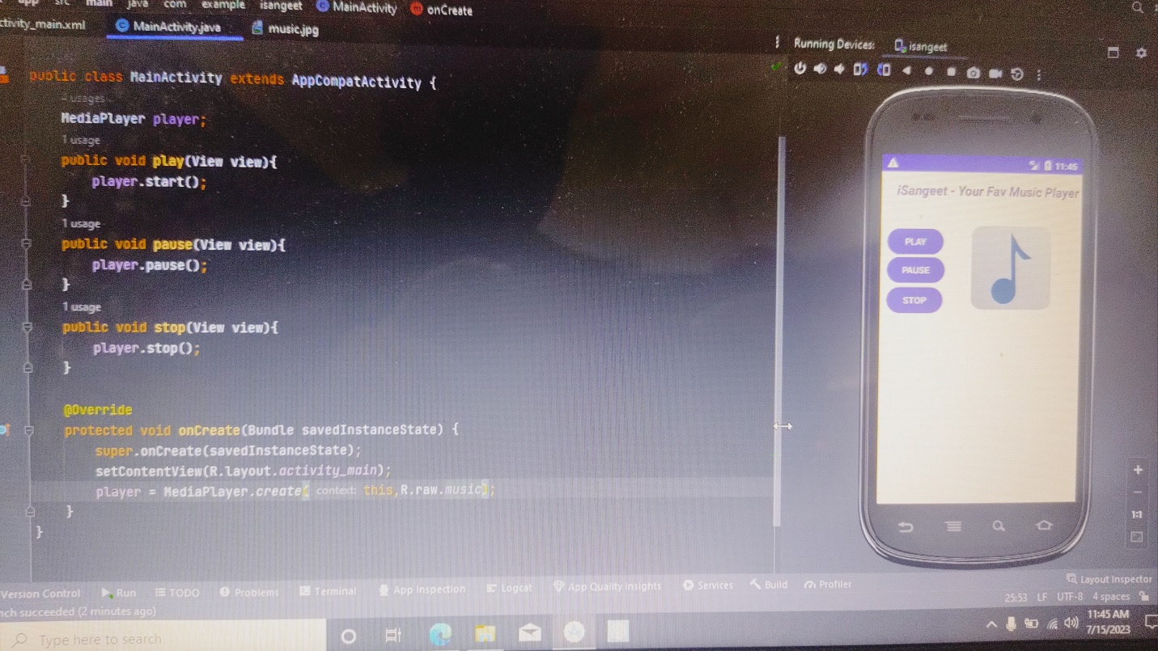

* **Setting up the Seekbar in music player**

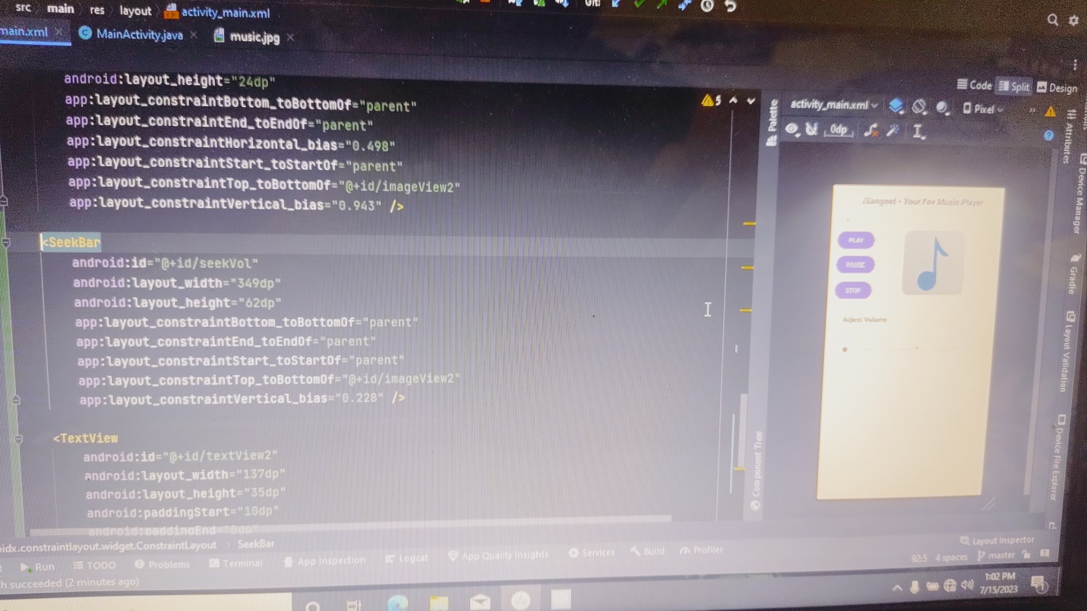

* **Challenges Faced:**

1. Faced while setting up the volume seekbar to access System service of max and min volume.
2. After stopping the audio using stop unable to resume music using play button.

* **Next Week Objective:**

Working on the seekbar to access and change in volume .

Resume the song where it has been stop.

Working on the interface of the iSangeet app.

Git hub link - [anuragsingh-003/iSangeet (github.com)](https://github.com/anuragsingh-003/iSangeet)